NEW GLOBAL IP VSATPHONE FOR SERVICE PROVIDERS

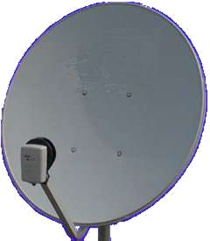
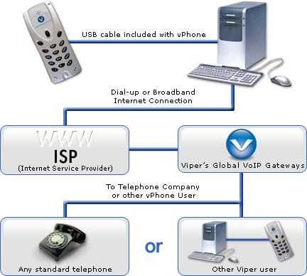
GLOBAL IP VSATPHONE

HOW IT WORKS
Satellite
ISP Provider

Telematics Business Consultants (TBC) with Viper Networks are launching this quarter a new GLOBAL IP VSAT PHONE solution for satellite service providers and carriers. This USB GLOBAL PHONE provides more options for clients that need to call the PSTN from IP VSAT terminals anywhere in the world.

The main advantages of this GLOBAL IP VSAT PHONE are:

- Global IP roaming with no charge and number Global Portability with voice quality.
- Pre-Paid Services with rates starting with 1 cent per min. (average 3 cts per min. main cities in the world)
- Calls between VIPERHONES is no charge
- Receive calls from a US or European numbers no charge
- Activation and account set up via Internet browser in 3 minutes anywhere in the world
- IP GLOBAL VSAT PHONE wholesale price start with less than US$ 40.00 per unit (Volume Discount)
- Pay only for the minutes used. No monthly fees, contracts or hidden charges.

Minimum System Requirements:
-PC Windows 98 or XP
- Use only 8 Kbps or equivalent of 12 Kbps in space segment base in tests of VSAT IP Platforms
-Easy to use and Install: Customer needs only to plug in phone to PC via supplied USB cable and download dialer software from VIPER website.

If you need any further information or would like to provide this solution for your VSAT IP base clients contact TBC- Telematics Business consultants via email info@tbc-telematics.com or via phone + 1-949-552-6871.

