Exploring the FSS Satellite Service Market

by Bruce R. Elbert
President, Application Technology Strategy, Inc.

The geostationary orbit continues to be home to nearly 250 communications satellites representing a substantial investment by satellite operators. The leading commercial companies that offer Fixed Satellite Service (FSS) capacity enjoy a solid business that yields relatively steady profits and even growth.

General Climate

The FSS satellite business has been marked by stable growth and profitability due to steadily-increasing demand for a broad range of applications. Mergers and joint ventures among FSS operators in recent years have produced a rational environment for the sale and application of capacity at C and Ku bands. North America, in particular, provides a very solid base for Intelsat, SES Americom, Telesat and Loral Skynet. In Europe, SES Astra and Eutelsat dominate and deliver what has become the primary vehicle for television distribution.

A region of strong growth is Africa, where satellite transmission is fundamental to the extension of basic voice, radio and video outside of major capitol cities. Asia has long relied on GEO satellites to fill the void in basic telecommunications infrastructure. The region still suffers from an oversupply of satellite capacity, which is an opportunity for those who can exploit these resources and employ related technologies now available on the world market. There are even new operators appearing who have taken over assets that were languishing. Asia Broadcast Satellite (ABS), a newly formed satellite operator that acquired the LMI-1 satellite positioned at 75 Degrees East. The LMI-1 satellite, a high-powered Lockheed Martin A2100AX spacecraft, covers four continents and over 4 billion people from Europe, Asia, the Middle East, Africa and Australia. Tom Choi, CEO of ABS, says the company will acquire a second satellite to further expand their service offerings. Protostar is a startup that will initially offer trans-Asia services using what was formerly known as ChinaSat 8. Phil Father, President and CEO of ProtoStar, announced at Satellite 2007 that Protostar 1 will be launched by Arianespace during the first half of 2008.

While 50% of all GEO FSS capacity is owned by only five companies, there remains a fairly vibrant market for national operators who focus on their domestic needs. Satellites have been launched for many nations, including China, Indonesia, India, Argentina, Brazil, Egypt, Philippines, Singapore, and others. More recently, Thai FSS operator Thaicom became a major player in Asia-Pacific by launching an end-to-end satellite service called IP-Star. This uses a combination of Ku and Ka-bands, along with low-cost VSATs, to provide broadband access through partnerships with other providers. Having created its own satellite and launch industry, Chinese manufacturers have been aggressively pursuing the international market. Venezuela and Nigeria have taken up Chinese companies on their offer to provide domestic satellites. The long term prospects for national satellite operators are somewhat uncertain as the respective markets may or may not sustain such investments. On the other hand, these companies typically have strong national and regional loyalties, which is attractive in the event of mergers among these and the larger operators.

Addressing Challenges

A handful of satellite failures and anomalies have forced major users to incorporate backup systems and capacity into their architectures. Overall, service reliability has been held above the 99% level, with some satellites achieving effectively 100%.
Getting new GEO satellites into orbit has been complicated by changes and events that affect the provision of launch services. Recently, Lockheed Martin sold off its interest in International Launch Services (ILS), a successful international joint venture that offered the Proton and Atlas rockets. Many satellites have been placed in orbit by this innovative organization from places not thought likely as commercial facilities. ILS is now privately owned and continues to serve the market. With regard to another successful international effort, Boeing SeaLaunch has begun to offer launches from Baikanur, Kazakhstan; SeaLaunch recovering from the damage caused by a Zenit rocket failure on its heretofore highly successful Pacific Ocean floating platform. Arianespace, as a result, is enjoying a boost in its business, having resolved basic issues with its heavy lifting Ariane 5 rocket.

Ku band is King

The first Ku band satellites were launched in the late 1970s and early 1980s but didn’t draw substantial business for many years. SBS 1, first operational in 1981, was limited to private network telecom services for major corporations (a business that failed, to be replaced by satellite news gathering and the first VSATs) and Satcom K helped NBC establish a nation-wide video distribution presence. Otherwise, C-band was the primary means of contributing and distributing TV for cable TV and most TV networks, namely CBS, ABC, PBS, HBO, Turner, and others. When Fox started up, they immediately chose the proven means of C band.

Direct-to-user services were a different story. By 1990, it was a fait accompli that Ku-band could directly-broadcast TV signals and provide voice and data services with adequate - if not carrier-grade - reliability. Today, Ku-band is the paramount earner among satellite assets; according to SatNews Daily, DBS’ penetration into cable’s market continues, currently reaching a 29% market share.

New Ku-band FSS satellites are under construction that will both increase in-orbit capacity and allow new services to be extended across a wider footprint. For example, a joint venture between Intelsat and JSAT International, the US subsidiary of leading Asian satellite operator JSAT, will soon launch Horizons 2 into 74 degrees West Longitude. This new GEO satellite from Orbital Sciences replaces the venerable SBS-6 that is well past its original mission life. Services on Horizons 2 will include traditional SNG and video backhaul as well as VSAT data communications. Two unique features will give Horizons 2 greater extension into specialized markets within national defense and disaster recovery. In addition to the FSS Ku-band standard 36 MHz transponders, Horizons 2 also contains 72 MHz transponders that facilitate very high data rate data exchange and broadcast. The footprint of Horizons 2 covers Continental United States (CONUS); in addition, it has the ability to focus a beam on the eastern seaboard.

---------------------------------------

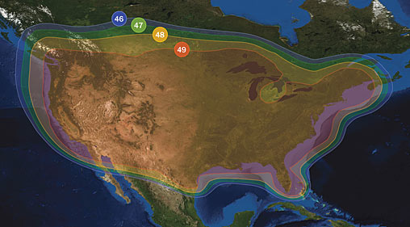
Anticipated Continental United States (CONUS) coverage and EIRP of the Horizons 2 satellite at 74 degrees West Longitude (courtesy of JSAT International Inc.)

Due to the greater demand for Ku-band capacity in the US, Intelsat and JSAT International have agreed to accelerate the launch schedule and make Horizons 2 available for service in the later part of this year. Already in orbit at 127 degrees West Longitude and operating at peak performance and capacity is Horizons 1, the first satellite of this cooperative venture. Another development is the entry of Echostar, operator of the Dish Network, into the Ku-band FSS market in the US. In general, demand for Ku-band services continues to grow throughout North America and Europe on satellites operated by Intelsat, SES and Eutelsat. Applications in FSS keep evolving; broadband is the baseline, with more usage for HDTV broadcasting, SNG, remote access, disaster recovery and military applications, and enterprise content distribution.

In terms of Ku-band innovation, Tom Navasero, Executive Chairman of International Mobile Broadcasting (Singapore), is proposing to offer mobile TV to handheld S-band receivers throughout a broad Asian footprint. Rather than actually delivering the signal from an S-band satellite, IMB would use existing Ku-band satellite capacity to distribute the TV signals to head-end terminals that employ S-band rebroadcast transmitters. The current relative oversupply of satellite capacity in Asia allows entrepreneurs like Tom to offer services without major investment in space.

C band for Global Reach and High Availability

The majority of satellites are still C-band and their coverage is truly global in nature. Because the first commercial GEO satellites operated at C-band, there are many legacy systems in place that continue to deliver value for operators and users. This foundation assures that much of the C-band capacity in orbit will stay occupied. On the other hand, the inherent benefits of C-band relative to Ku- and Ka-bands will give this medium a strong future.

Among these benefits are the fact that C-band links are nearly impervious to rain attenuation and the resulting fading that impacts quality of service. This is of concern to applications that demand high reliability, such as cellular backhaul and TV distribution to local TV stations and cable systems. New applications that require high quality of service include broadband data transfer in energy development, operations, manufacturing, national defense, and health care.

The other strong suit for C-band is the global coverage that comes from having so many satellites positioned throughout the geostationary orbit. Intelsat continues to dominate this field as its satellites are centered on the three ocean regions and offer broad footprints. Remote Pacific islands as well as developing countries of South America and Central Asia depend on C-band capacity to overcome a wide variety of obstacles. The larger dish required for C-band as well as spectrum sharing with terrestrial microwave are not of great concern to these customers.

New Space Segment at Ka-band

Occupying the far end of the radio spectrum, Ka-band satellites are still relatively nascent as to their application in the commercial marketplace. The technology was developed 30 years ago in Japan, Italy and the US; however, commercial usage lagged somewhat. The Iridium LEO voice system was the first to exploit Ka-band commercially, although its use was limited to inter-satellite connectivity and links to the gateway earth stations. In Japan, NTT developed a Ka-band system for broadband connections between cities and remote islands. But domestic satellite services evolved in Japan primarily through Ku-band, which was applied successfully to the SkyPerfect DBS service. Recently, SkyPerfect and JSAT merged to form a single company, SkyPerfectJSAT.

Direct-to-user applications at Ka-band are growing in the US as a result of WildBlue producing a viable consumer broadband service. Now with their own satellite manufactured by Space Systems/Loral, WildBlue can aggressively compete with existing Ku-band providers and may take a bite out of land-based fixed line and wireless broadband offerings. Hughes Communications (formerly known as HNS) will launch a new Spaceway Ka-band satellite that will ratchet up broadband service capabilities, making VSATs even more attractive to enterprise and government customers.

---------------------------------------------------

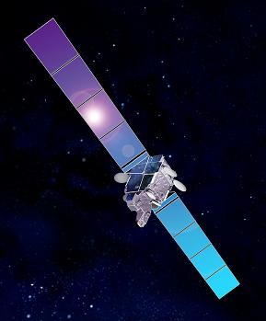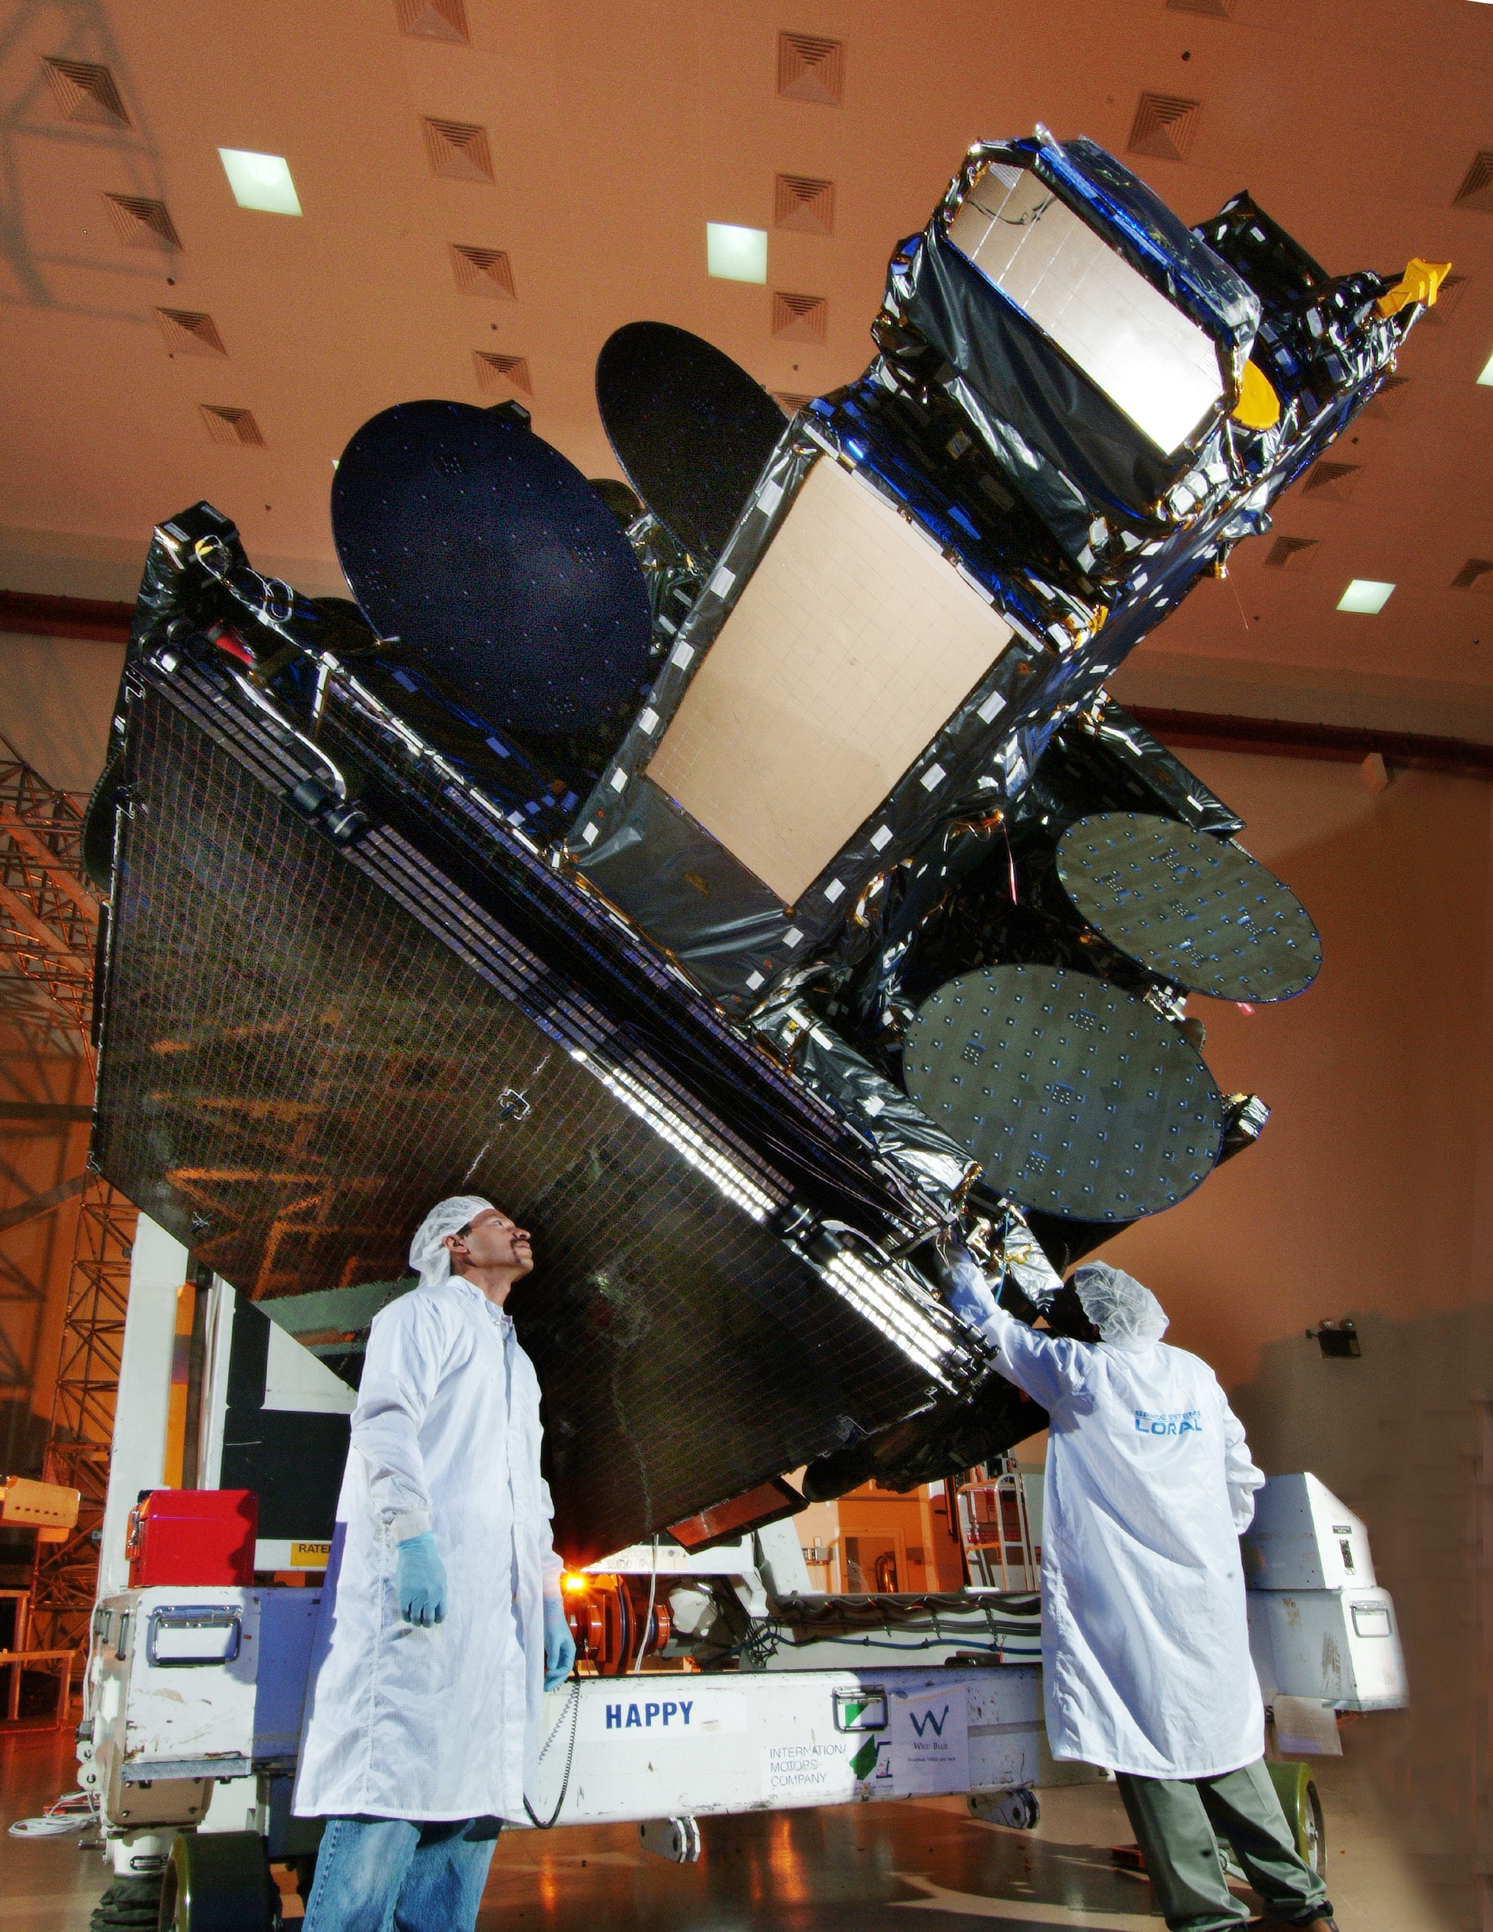

Caption: On the right is the WildBlue-1 satellite at the Space Systems/Loral sassembly facility in Palo Alto, California where it underwent final inspection before being shipped to the launch site in Kourou, French Guiana. At left is an artist conception of the satellite in orbit. (Photos: courtesy of Sergio Maraschin, Space Systems/Loral)

---------------------------------------
Promising FSS Future

The glitter is not off the FSS rose. In fact, the investment community is again following the FSS business and major operators are finding that they can obtain the financing they need. The fact that there are two new operators in Asia who financed their satellite acquisitions testifies to the confidence in the future of basic satellite infrastructure in years to come. Furthermore, spacecraft manufacturers are enjoying an upswing in orders from existing operators even during a period when other telecom and wireless investment is stagnant. The more recent surge in new wireless capabilities and introduction of fiber-to-the-home have not significantly dulled the luster of satellite communications.

Insert Bruce bio and photo here (pickup from Nov. 2006 issue)

