Case Study

CSM systems are evolving into tools that Broadcasters must have to deliver interference free HD content
by Bob Potter
Traditionally, broadcasters, with one carrier per transponder have had very limited use for a traditional communications system monitor (CSM) system, or carrier management system. A wall of TV screens was sufficient to tell the broadcasters that the signal quality was acceptable or not. The advent of localized programming with multi beam satellites and digital HD TV requires tools that offer a little more sophistication. However MCPC carriers still allow broadcasters to use one carrier per transponder, and the belief that this makes them immune to interference. More than once I have heard “we do not have interference on our satellites”.
As services have moved into the digital age so has the traditional CSM system, and it should now be more properly viewed as an interference detection and analysis tool.
Most geostationary broadcast satellites experience some kind of interference from time to time. The impact on the operators bottom line can be linked to how quickly the interference can be detected and removed (customer satisfaction), or avoided which in turn can be directly associated with the investment in state of the art tools for interference detection, analysis and location. It may be that initially the interference is not sufficient to significantly degrade the picture quality, however understanding that the interference is present and needs to be removed before it does become a problem to picture quality will only become more essential as TV content moves to high definition formats.
With the advent of new digital technology it is now possible to quickly detect and analyze interference anywhere in the transponder, even within the bandwidth of an MCPC carrier without having to drop the main carrier from service. Once the interference is detected and analyzed, various tools can be brought to bear to assist with quickly removing the interference form the satellite, causing minimal impact upon customer services. For example, SIURG organization determined that >90% of all interference is accidental and caused by carriers known to the satellite operator. Thus, by “fingerprinting” the interfering system characteristics and mining the satellite operators own carrier database, you can quickly resolve over 90% of all interference problems.
Modern CSM systems using fourth generation digital spectrum analyzers (DSA), capable of time domain measurements that allows for interference detection and analysis, including fingerprinting of interfering carriers (even ones underneath existing carriers), as well as providing the familiar look, feel and measurement capability of the traditional spectrum analyzer. Products with these advanced capabilities are currently only available from companies like SAT Corp, and their MONICS® family of products which includes SAT-DSA™, are now available which provides greater instantaneous bandwidth and instantaneous dynamic range than any other product on the market today. When combined with the latest cost effective powerful computers and Digital Signal Processing (DSP) algorithms, they provide fast spectrum measurements as well as time domain measurements.
MONICS®/SAT-DSA™ automatically recognize and measure modulation formats, recognize all carrier types in use on FSS and BSS satellites including DVB-S2 format such as 16 & 32 APSK, but also symbol or bit rate, C/No, C/I, Eb/No and FEC (supporting DVB-S and DVB-S2). In addition, using the SAT proprietary “carrier under carrier”™ analysis capability, you now have these same capabilities for detecting and recognizing (i.e. fingerprinting) interfering carriers that sit under the primary carriers.
This is achieved by digitally removing the main carrier to reveal, and the noise and interference across the entire bandwidth under the carrier, essential for one carrier per transponder operations.
MONICS® unique carrier under carrier™ display coupled with modulation analysis measurements means that it can automatically detect if interference is present within the bandwidth of an authorized carrier and analyze the interference.
Once it is known that interference exists Monics® automatically performs analysis on the interfering signal, even if it is within the bandwidth of an authorized carrier and produce modulation type, symbol rate/data rate, shaping factor and FEC as well as bandwidth, center frequency.
It is also possible to analyze multiple carriers that may be causing interference; Figure 1 shows that two carriers can easily be analyzed.

Figure 1 Analysis of Multiple Interferers
This technique can also yield other valuable information for broadcasters, for SCPC it confirms quality of service in a remote beam, confirming interference free transmissions with correct Eb/No, for MCPC, PID information, channel occupancy and channel parametrics can now be extracted, allowing broadcasters to monitor their traffic in remote beams and be assured of the quality of service. A typical display of RF analysis along with digital analysis of occupancy is shown below in figure 2.

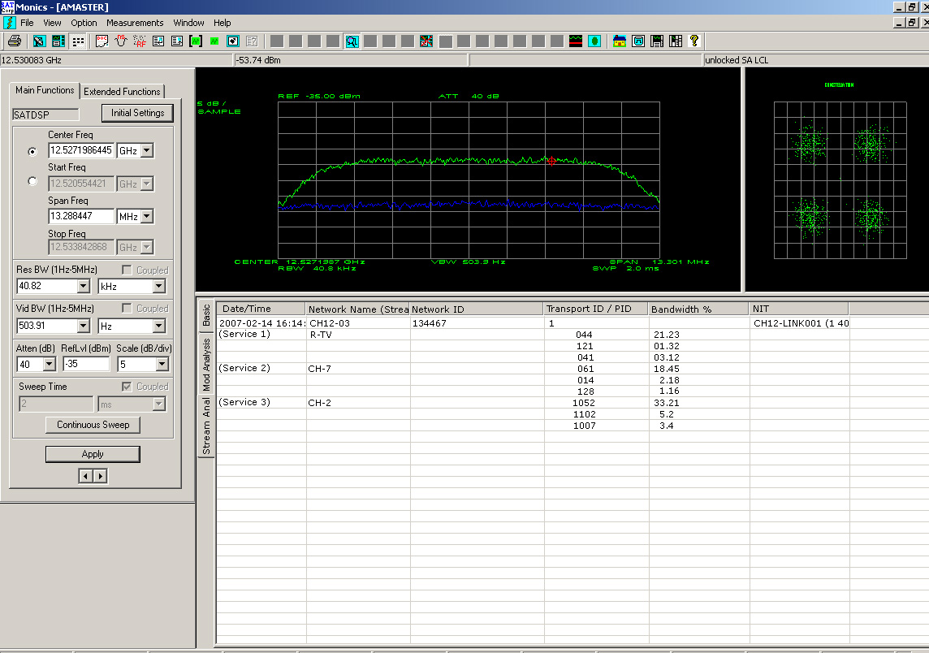
Figure 2 Analysis of Carrier and Streams
From this display the operator can see both the RF performance and the analysis of the individual channels within the DVB carrier
Fourth generation DSAs can now extract the Network Information Table (NIT) from the DVB stream, so if another uplink station is causing interference it is possible to extract out from the NIT table the location of that particular modem.
With digital DSP techniques, the new modern CSM systems, such as Monics®/SAT-DSAT™, adds interference detection and analysis to the armory of the satellite operator / service providers. Broadcasters can now determine the level of interference under their single carrier per transponder and characterize the interference, and in most cases resolve the interference problems quickly and easily. Digital CSM systems also combine interference analysis with traffic or protocol analysis, being able to display PID and channel occupancy information and extract the network information table to confirm location of the modem. CSM systems can now provide the quality of service parameters needed to ensure delivery of HD content.

Insert Bob Potter photo here

Bob Potter is President of SAT Corporation, Sunnyvale CA,. . Previously Mr. Potter held the position of R&D Manager with Maxon Europe Limited based in Hemel Hempstead, UK. Mr. Potter graduated from Southampton University, UK with a B.Sc.(Hons) degree in Electronic Engineering and has 20+ plus years of experience in RF System design and RF measurement techniques. He can be reached at bob@sat.com

